**User Manual For Android**

1 Home Page

1.1 Sign up

1.2 Sign in

1.3 Forget Password

2 Market Display

2.1 50ETF

2.2 50ETF Option

3 Build Portfolios

3.1 Asset Allocation

3.2 Hedging

3.3 DIY

4 My Portfolio

5 Message View

6 Personal Information

1 Home Page

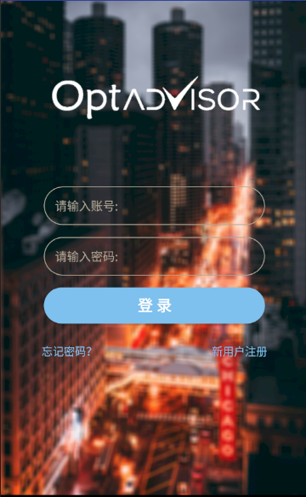

1. Click the “Sign up for new users” button and get to the sign up view registering to be new users of the system. Your account information can be used both in web application and android application.
2. After inputting the correct account and password, click “Sign in” button and get to the home page to use more functions.
3. The system will send an alert when account and password are not matched.
4. Click “Forget password?” button and get to forget password view (see 1.3). Use mobile phone verification code to get back your password.
   1. Sign up

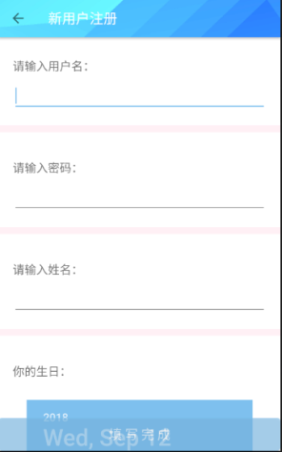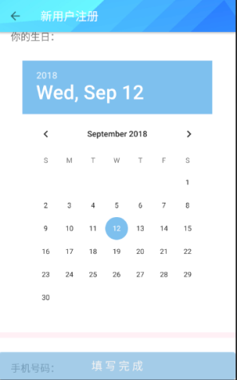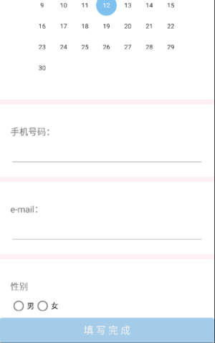

After inputting necessary information, you can get to the questionnaire view. The system will formulate your own investment plan based on your results. Click “Finish filling in” and get back to the sign in view.

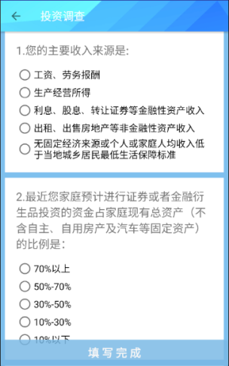

1.3 Forget password

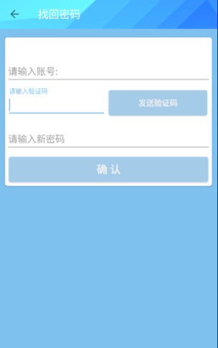

Click “Send verification code” after inputting your account and the system will send SMS verification code to your binding mobile phone number. Input correct verification code and your new password then click “Confirm” button finishing resetting your password. The system will jump to sign in view after resetting. You may not be allowed to send another verification code within continuous 60 seconds.

2.Market Display

Click “50ETF” button and check 50ETF market (see 2.1)

Click “Option” button and check 50ETF option market (see 2.2)

2.1 50ETF Market

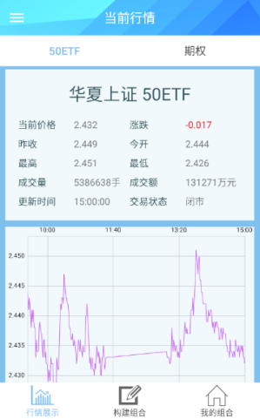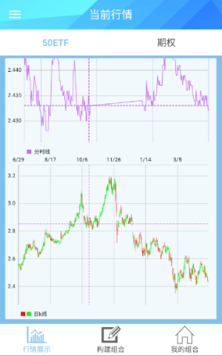

Hsia 50ETF market information can be seen in this view, which is divided into timeline diagram and daily K-line diagram.

2.2 50ETF Option Market

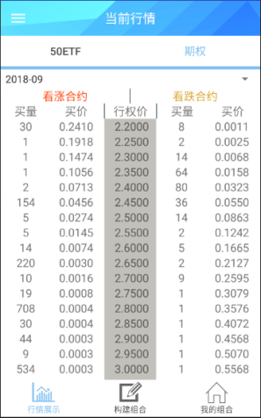

You can select the month you want to view at the top of the screen, drag the screen left and right to see the full options information

3. Build Portfolios

Click the “asset allocation” button to enter the asset allocation view (see 3.1)

Click the “hedging” button to enter the hedging view (see 3.1)

Click the “DIY” button to enter the DIY view (see 3.3)

3.1 Asset Allocation

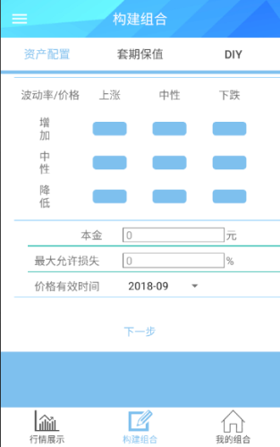

The Market Expectations section of the page offers eight options (the middle button is not clickable), and individuals click the corresponding options based on their expectations of future 50 ETF prices and volatility.

After selecting expected preference, fill in the principal and tolerant maximum loss ratio, select the price effective time, and drag the slider or click on the progress bar at any location to select the corresponding expected price and expected volatility.

When the selection is complete, click the next button, and wait for the system to calculate. When the calculation is complete, the system will enter the recommended portfolio view.

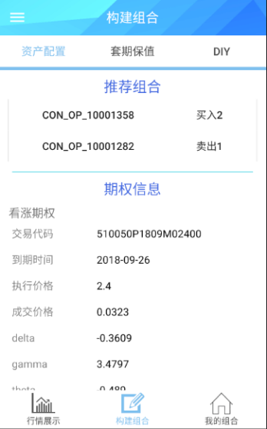 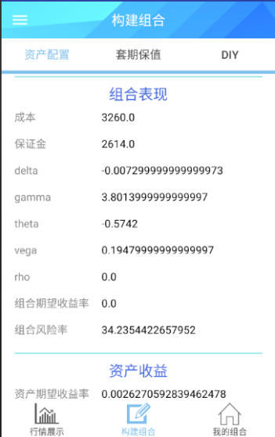 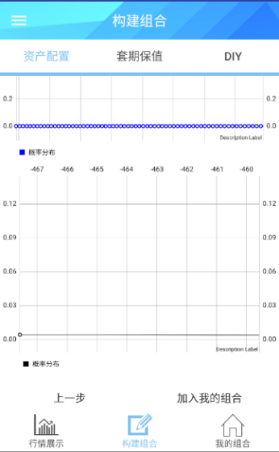

Click on the options in the portfolio and view the detail of the options

Slide down to see the combined performance of the portfolio

Slide down to see the portfolio returns at different underlying prices, the probability distribution of portfolio returns in the expected market, and the probability distribution of portfolio returns in the historical market, which are presented in three charts.

Click “the last step” button and get back to the build portfolio view.

Click “add to my portfolio” button and add the portfolio to your account.

3.2 Hedging

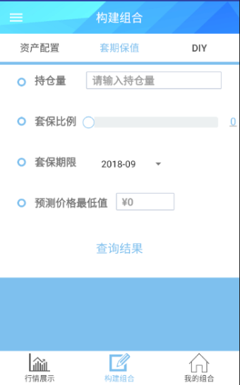

Input position, hedging ratio and the lowest predicted price, select the hedging period, and wait for the system to calculate. After the calculation, the system will show the hedging effect display.

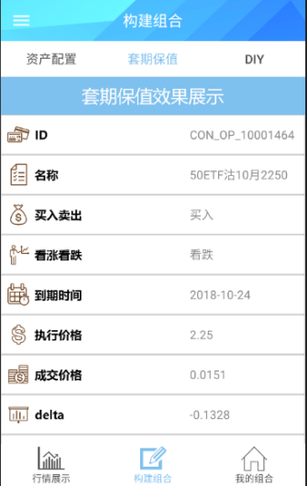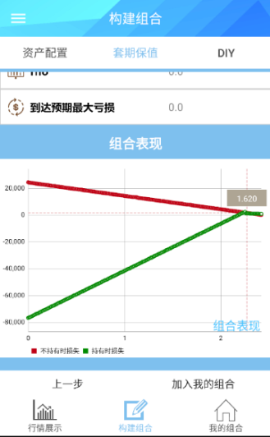

Click “the last step” button and get back to the build portfolio view.

Click “add to my portfolio” button and add the portfolio to your account.

3.3 DIY

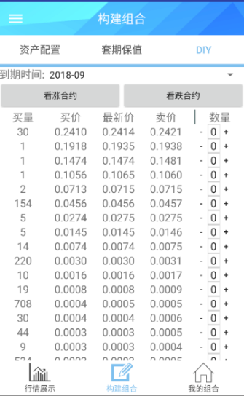

Click on the “call contract” button to switch the contract type.

Select date in date picker frame.

Enter the number of options in the box corresponding to the option, and the negative number is selling, while the positive number is buying.

Click “submit” button and add the portfolio to your account.

4.My Portfolio

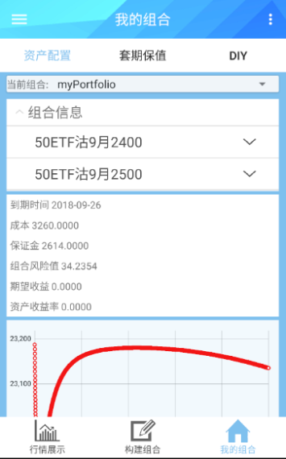

Click "Asset Allocation", "Hedging", "DIY" to switch the combination type and change the shown chart type.

Click “current portfolio” to switch current portfolio.

Click “portfolio information” to expand the option list.

Click option to see the details.

Click “portfolio information” twice to pick up the option list and option details.

Click menu at the right top corner of the page.

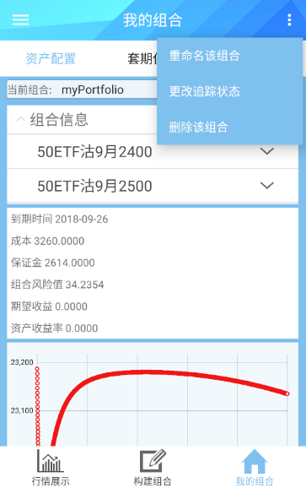

Click “rename the portfolio” to rename current portfolio.

Click "change tracking state" to modify the tracing state of the current portfolio. When a portfolio is tracked, the system sends prompt information to the user if there is too much loss.

Click “delete the portfolio” to delete current portfolio.

5 Message View



In the message page, pull down the current page to refresh the message.

Click on the message to get to the message detail view.

In the message detail page, click the button to delete current message.

6. Personal Information

Click “Personal Center” button to get to the personal information view.

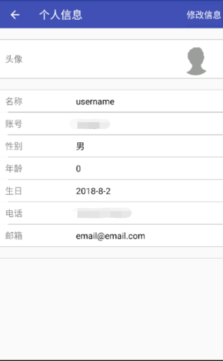

Click “modify information” button to modify information such as name, but it is not allowed to modify the account number.

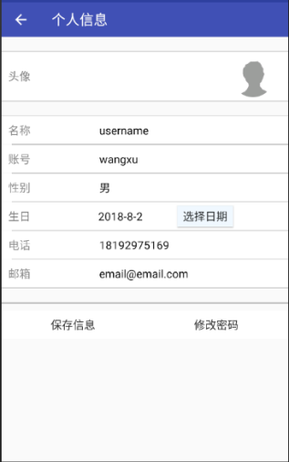

Click “save the information” to save the information modified.

Click “modify the message” to get to the message modifying view.

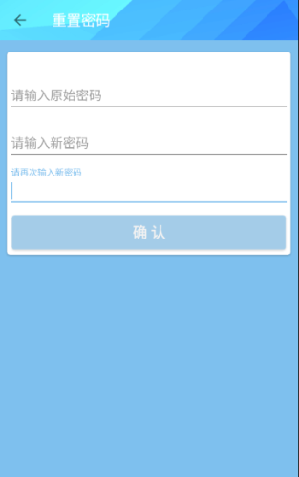

Enter the original password, enter the new password twice, and click the "confirm" button to save the new password.